1. Overview
The acoustic project investigates whether acoustic signals recorded during SuperCam Laser-Induced Breakdown Spectroscopy (LIBS) analyses contain useful information about geological variability in Jezero crater. Each LIBS laser shot produces an acoustic signal that is recorded by SuperCam’s microphone, and the project focuses on extracting measurable differences in the time and frequency metrics of those signals.
The work began with Crater Floor observations, primarily comparing targets associated with the Maaz and Seitah formations and their respective rock members, initially focusing on reverberation metrics such as decay rate and C2 and their possible relationship to rock porosity or other physical properties. The project was later expanded to include FFT-derived frequency metrics and observations from the Delta Front and Upper Fan.
The current combined dataset contains 293 SuperCam LIBS acoustic observations spanning sols 37-907. The main goal at this stage is to evaluate whether acoustic metrics differ systematically between the Crater Floor, Delta Front, and Upper Fan, and to determine which metrics provide the clearest separation between these regions.

2. Dataset
The acoustic data were obtained from the publicly available Mars Analyst Notebook maintained by NASA's PDS Geosciences Node at Washington University in St. Louis. All observations originated from SuperCam FITS products. Earlier Crater Floor recordings were converted to WAV files before analysis. For the Delta Front and Upper Fan expansion, the downloaded SuperCam products were retained as ZIP archives because of an extraction/access issue encountered during processing. The workflow reads the relevant FITS product from each archive, extracts the SOUND arrays, and writes concatenated multishot WAV files before the selected shot is analyzed.
The initial Crater Floor dataset covered sols 37-365 and included observations from the Maaz and Seitah formations. Targets were grouped by geological members where possible, including Artuby, Nataani, Roubion, Cha’al, Rochette, Caille, Bastide, Content, and Undivided. These categorizations were based on the classifications used in Alvarez-Llamas et al. and cross-referencing SuperCam imagery with the physical characteristics of the rock members.
Out of the 6 different types of targets across the rover traverse, the analysis focused only on the bulk category which consists of rocks at least centimeter-size. This basis of categorizing observations as bulk as opposed to regolith, drill tailings, etc is consistent with Alvarez-Llamas et al.
The dataset was later expanded to the Delta Front (sols 417-703) and Upper Fan (sols 706-907). After processing and quality control, the combined dataset contains:
- Crater Floor: 185 observations
- Delta Front: 53 observations
- Upper Fan: 55 observations
Additional Delta Front and Upper Fan observations were collected but remain excluded because they require further quality control or could not be processed reliably. These files have been retained for possible future recovery.
The final combined CSV contains the identifying metadata, geological classifications, onset information, and calculated acoustic metrics used for the statistical analysis and PCA.

3. Processing Methodology
SuperCam acoustic data are sampled at 100 kHz. LIBS targets are observed at multiple positions along a raster, with multiple laser shots at each position. For consistency, the second laser shot at the first raster position was used for each target. This also reduces the potential influence of loose surface material affecting the first shot.
An automated procedure was used to identify the onset of the LIBS acoustic response. The algorithm detected the main acoustic peak, identified the preceding signal onset, and calculated the peak-onset lag. Recordings with failed peak detection, extraction errors, or anomalous peak-onset timing were flagged for review. Flagging criteria were refined during the project as the onset-detection workflow developed. Flagged signals were manually inspected and corrected where a clear onset could be identified; otherwise, they were excluded from the final dataset.
The same general onset procedure was maintained throughout the project so that measurements from the Crater Floor, Delta Front, and Upper Fan remained comparable.
The Crater Floor dataset underwent several rounds of manual review as the onset-detection procedure was refined. The Delta Front and Upper Fan data were processed with a more standardized pipeline, although a subset of those observations still requires additional review and has been retained separately for possible future recovery.
Once the acoustic onset was identified, a 10 ms window beginning at the onset was extracted from each signal. All primary time- and frequency-domain metrics were calculated from this window.
Using a fixed post-onset window ensured that each observation was analyzed over the same portion of the acoustic response and maintained consistency across the different regions and stages of the project. The resulting signal segment was then used to calculate the time-domain reverberation metrics and FFT-derived frequency-domain metrics described in Section 4.

4. Acoustic Metrics
Two groups of acoustic metrics were calculated from each 10 ms signal window: time-domain reverberation metrics and frequency-domain metrics derived from the Fast Fourier Transform (FFT).

4.1 Time-Domain Metrics
The primary time-domain measurements were calculated from the Energy Decay Curve (EDC), which describes how the acoustic energy decreases following the LIBS shot.
- Decay Rate: A linear fit was applied to the EDC between approximately −7 and −15 dB. This interval was selected to capture a relatively stable, approximately linear portion of the decay while avoiding the immediate post-shot transient and the lower-amplitude tail of the signal. Because the fitted slope is negative, the reported decay rate was taken as -slope in dB/s, so larger values indicate faster acoustic decay.
- C2: A clarity metric comparing the acoustic energy arriving within the first 2 ms after onset with the energy arriving afterward. Higher values indicate a greater proportion of early acoustic energy.
These metrics were initially chosen to investigate whether differences in reverberation behavior might relate to rock porosity or other physical properties.

4.2 Frequency-Domain Metrics
FFT analysis was later added to characterize the frequency content of each acoustic signal. The calculated metrics include:
- Spectral Centroid: The frequency-weighted center of the spectrum.
- Spectral Bandwidth: The spread of frequencies around the spectral centroid.
- Peak Frequency: The frequency containing the greatest spectral power.
- 85% Spectral Rolloff: The frequency below which 85% of the total spectral power is contained.
- Low-Frequency Power: Spectral power between 1-10 kHz.
- High-Frequency Power: Spectral power between 10-30 kHz.
- High/Low Power Ratio: Ratio of high-frequency to low-frequency power.
- High-Frequency Fraction: Fraction of the selected spectral power contained in the high-frequency range.
- Total FFT Power: Total spectral power within the analyzed signal.
These metrics were calculated using the same procedure for all observations and were later used in the regional statistical comparisons and PCA.

5. Statistical Analysis and Results
Regional differences between the Crater Floor, Delta Front, and Upper Fan were evaluated using Kruskal-Wallis tests for eight selected acoustic metrics used in the final regional analysis. Six of the eight metrics showed statistically significant regional differences. Spectral Bandwidth showed the largest effect by a substantial margin (H = 154.26, p = 3.19 × 10⁻³⁴, ε² = 0.525), followed by High Frequency Fraction (ε² = 0.274), C2 (ε² = 0.215), and Decay Rate (ε² = 0.201). Rolloff 85% and High/Low Ratio were not significant at a significance level of α = 0.05.
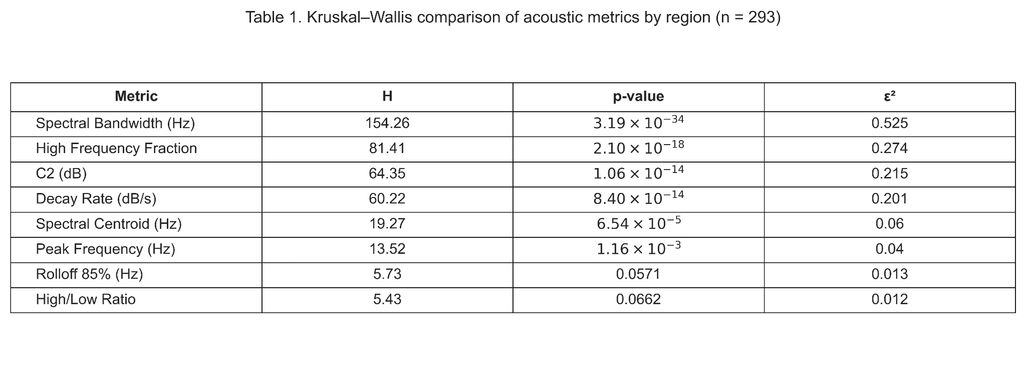
The regional boxplots in Figure 1 below show the four metrics that best summarize the observed differences while representing both the time- and frequency-domain portions of the project. Spectral Bandwidth and High Frequency Fraction showed the clearest frequency-domain separation, while C2 and Decay Rate showed the strongest differences among the original reverberation metrics.
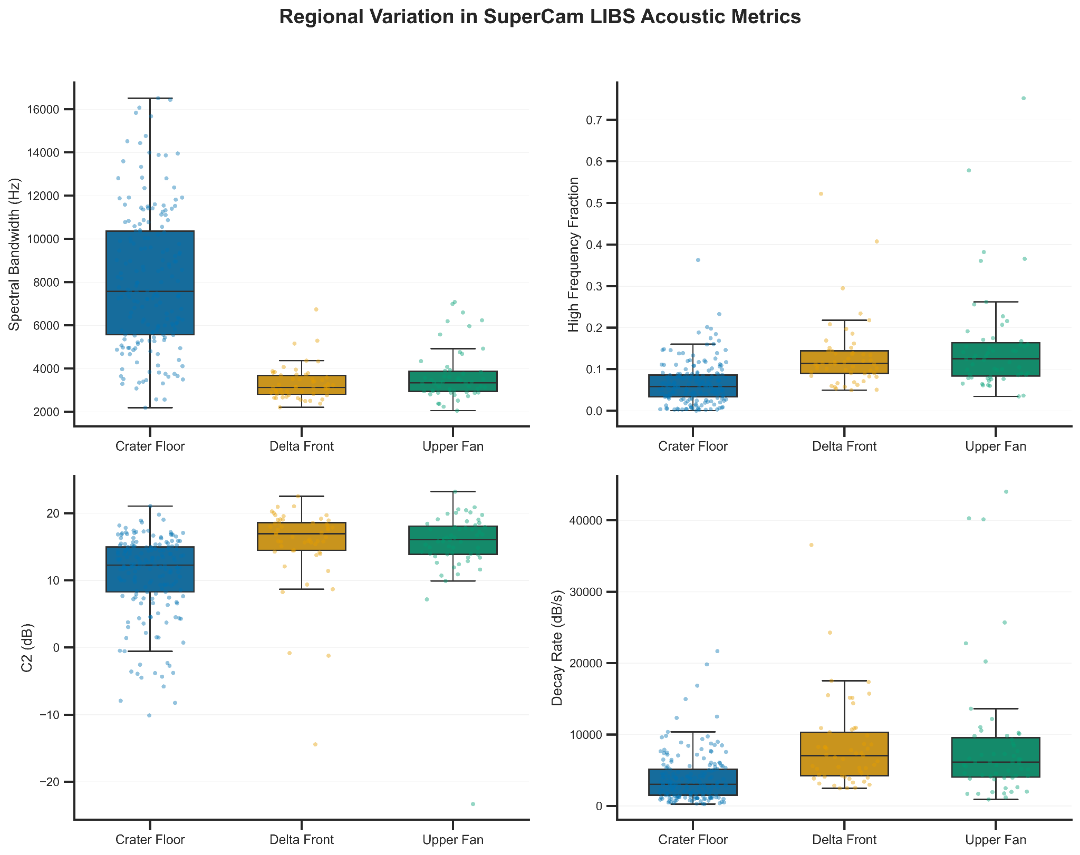Dunn’s post hoc tests were used to identify which regional pairs contributed to the significant Kruskal-Wallis results. The main differences generally occurred between the Crater Floor and the Delta Front or Upper Fan, while the Delta Front and Upper Fan were usually not significantly different from one another.
Principal component analysis (PCA) was also used to evaluate the metrics together. The PCA showed partial separation of Crater Floor observations from the Delta Front and Upper Fan, with substantial overlap between the latter two regions. This is consistent with the individual metric comparisons and suggests that the strongest acoustic change occurs between the Crater Floor and the later portions of the rover traverse.
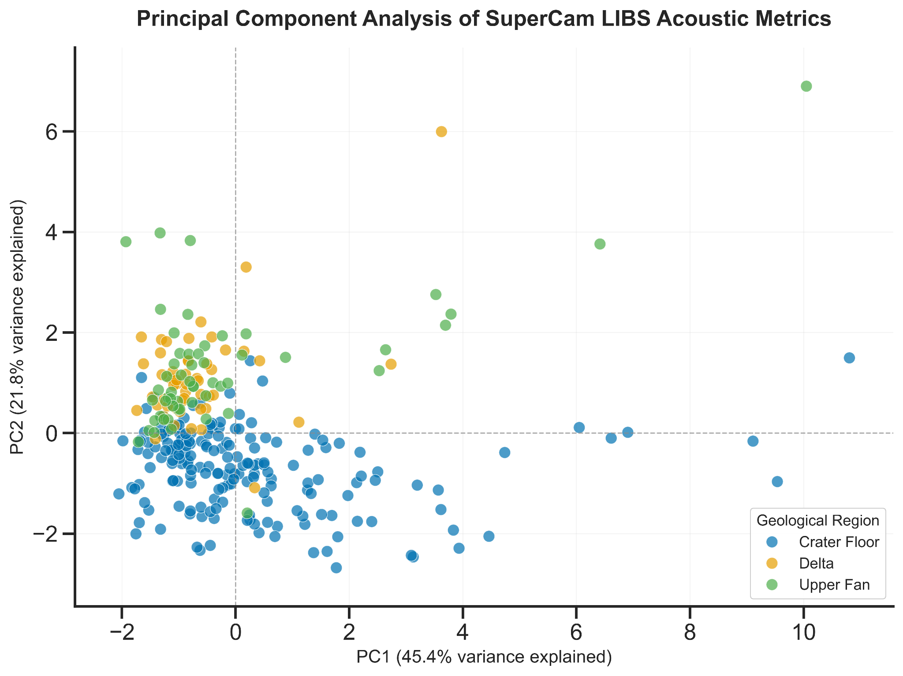
Within the Crater Floor, formation-level differences between Maaz and Seitah were much weaker than the broader regional differences. These crater-floor comparisons were part of the earlier phase of the project and are retained in the supporting analysis files.

6. Project Files and Repository
The project files have been organized into a GitHub repository containing the cleaned processing and analysis notebooks, final datasets, quality-control records, figures, supporting documents, and archived original notebooks. The repository README provides the recommended workflow, folder structure, data lineage, and instructions for reproducing the final statistical analysis.
The primary cleaned notebooks are:
01_crater_floor_processing.ipynb — Crater Floor acoustic processing and metric calculation.
02_crater_floor_qc_recovery.ipynb — Crater Floor onset recovery and quality control.
03_delta_upper_fan_processing.ipynb — Delta Front and Upper Fan FITS extraction, WAV generation, processing, and dataset merging.
04_statistical_analysis.ipynb — regional statistics, post hoc testing, PCA, and final figures.
The main datasets are stored in data/processed/. LIBS_acoustic_meta_sheet_v3_185.csv contains the final Crater Floor dataset, while LIBS_acoustic_meta_sheet_v4_293.csv contains the full 293-observation dataset used for the final statistical analysis.
Intermediate processing files and manual quality-control records are retained in data/intermediate/ and data/qc/, respectively. The original working notebooks are preserved unchanged in archive/original_notebooks/ for reference and provenance.
Raw acoustic source files are retained in data/raw/. The Crater Floor directory contains the retained FITS and WAV products, while the Delta Front and Upper Fan directories contain the original downloaded SuperCam products as ZIP archives used by the later processing workflow. The repository README documents the folder structure and processing sequence. For reproducing the final results, only the 293-row processed dataset and 04_statistical_analysis.ipynb are required.

References
Alvarez-Llamas, C., Laserna, J., Moros, J., et al. (2023). The sound of geological targets on Mars from the absolute intensity of laser-induced sparks shock waves. Spectrochimica Acta Part B: Atomic Spectroscopy, 205, 106687. https://doi.org/10.1016/j.sab.2023.106687

NASA Planetary Data System Geosciences Node. Mars 2020 Perseverance Analyst’s Notebook. Washington University in St. Louis. https://an.rsl.wustl.edu/m20/AN/an3.aspx. Accessed 2026

